Resources and Chatroom
There are many websites that provide information for most of the stocks around the world such as investing.com and Yahoo Finance. However, being involved in all stocks around the world makes these websites not the best for a specific country; it would be better if there is a website that targets a specific country’s stock. Since we target the US market in this course, we would like to find resources for the US market. Finviz is a good pick for the US market.
You can find a chatroom on Discord for the course (I joined it already).

Market Capitalization & Screening
Market capitalization (often shortened to market cap) is the total market value of a company. It is calculated by multiplying the current price of a company’s share by the total number of available shares. Companies are classified according to their market caps as follows:
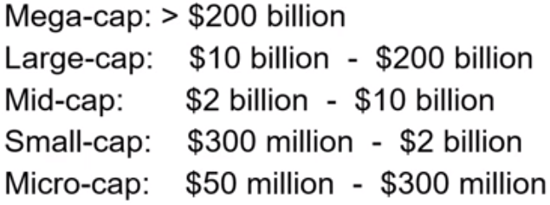
Example: on Yahoo Finance, if you searched for Netflix, you would find
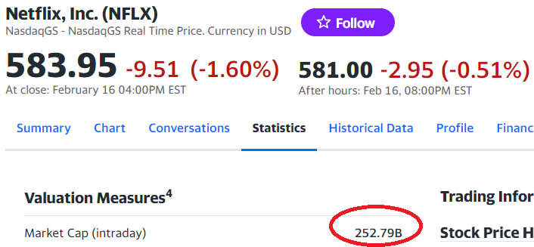
We can calculate it ourselves. The share value is 583.95 as shown above, and we can search for the shares outstanding as shown below:
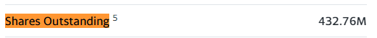
Thus:
$$432.76M×583.95=252.71 B$$
Screening: screening is the process of finding information. You can search for companies that currently have biggest market caps, companies whose stocks made the most profit today, and so on. So, let’s screen the companies with the biggest market caps. On tradeview.com, click Products Screeners Stock. You can now filter companies with many filters, but let’s stick to the market cap filter for now:
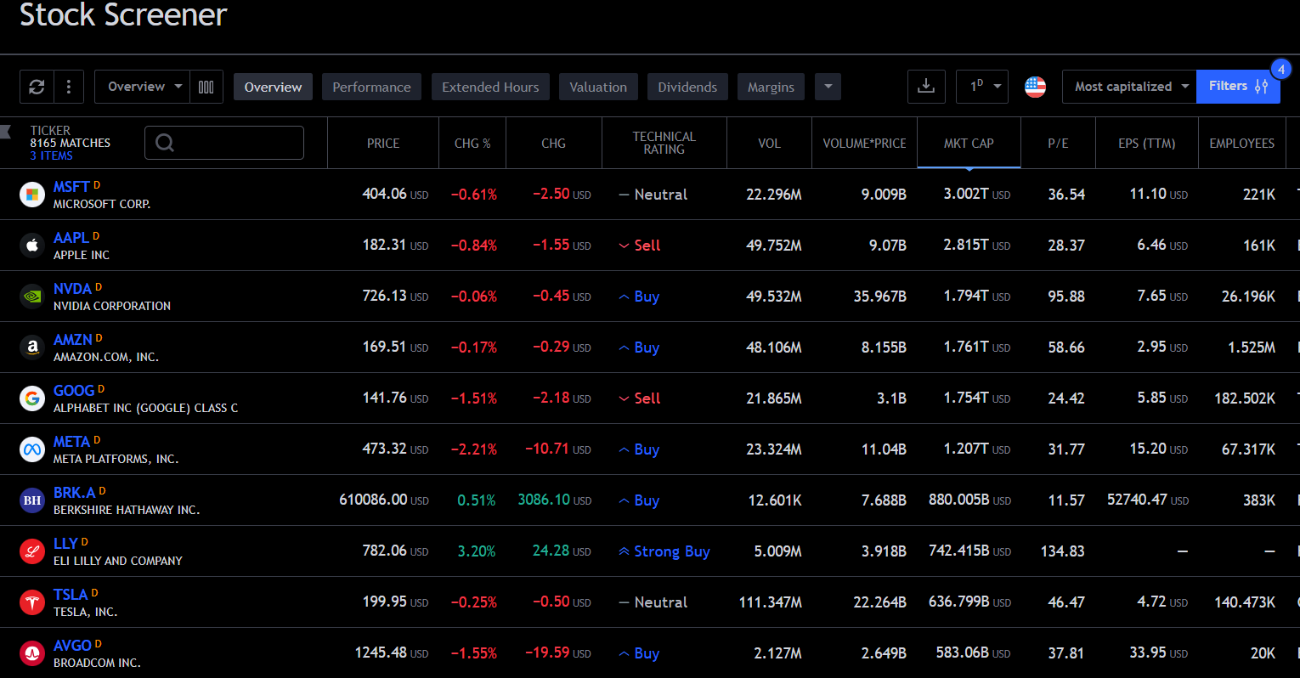
It is clear that Microsoft is currently the biggest company in the US with a market capital of 3 trillion dollars!

Financial Statements
Public companies are obliged to release financial statements on a quarterly basis. These statements are:
- Balance Sheet.
- Income/Earning Statement.
- Cash Flow Statement.

Balance Sheet
A balance sheet reports the company’s assets, liabilities, and equity. It also has a section for management discussions and analysis.
$$assets=liabilities+equity$$
$$equity=assets-liabilities$$
- Assets are everything that the company owns (cash, equipment, buildings, etc).
- Liabilities are the debts of the company. When company A lends $50M from company B, it said that company A has a liability of $50M, which is simply the debt value.
- Equity represents the value of an asset minus any liabilities. In simpler terms, equity is the difference between the value of something you own (like a house or a business) and any debts you owe on it. So, if a company has assets that worth $200M but the company owes the bank $50M, then the company’s equity is $150M. Imagine you as a person own many things (e.g. houses, cars, etc) that worth $100M, but you owe your friend $60M, so your net worth is effectively $40M. You can remember this: equity is the difference between everything you OWN and everything you OWE.

An example of a balance sheet is shown below:
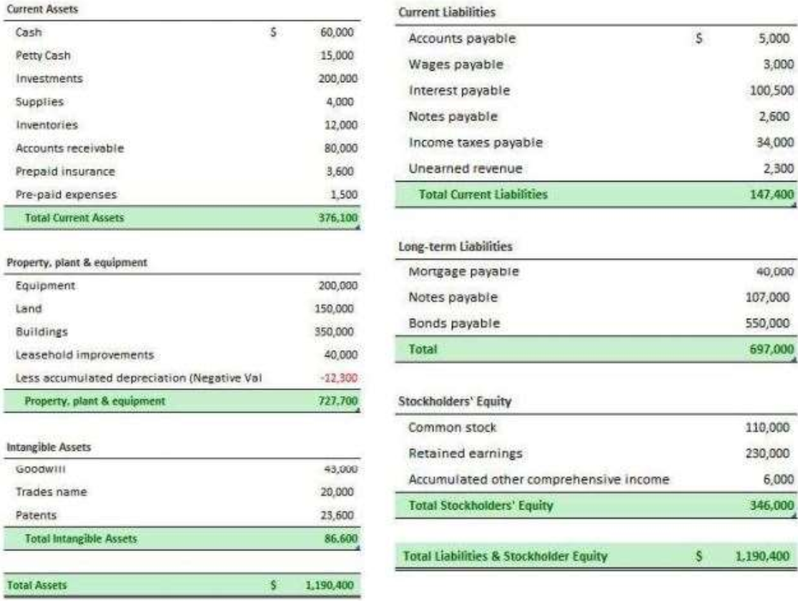

Income/Earning Statement
An income/earning statement reports the company’s financial performance. This is the form where the earnings are disclosed. It shows the company’s revenues, expenses, and net profits. Everyone waits for this statement to know the earnings of a company.
$$Net Profit=Revenue-Expenses$$
An example of an income/earning statement is shown below:
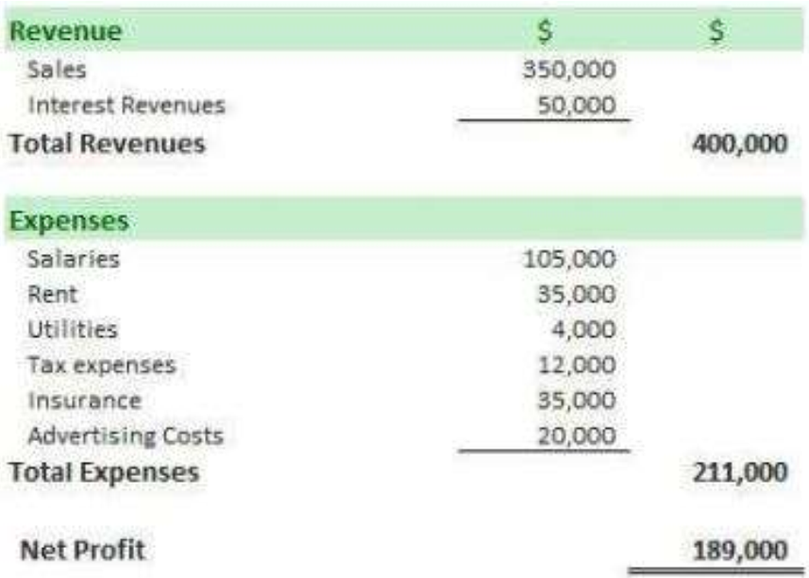

Cash Flow Statement
A cash flow statement shows the cash entering and exiting a company. It is divided into 3 parts:
- Core operations.
- Investing.
- Financing.
Although many people do not care about this statement, it is important because it shows you where the company got its profits from. For example, a company might have a big profit written in the income/earning statements, so you think that it is doing good and you begin thinking of buying stocks in it. However, when you check its cash flow statement, you might find that the company sold a building in this year, which increased its profit. So, it is important to check the cash flow statement of a company to know whether it made a profit from its core operation or from a non-recurring source.
An example of a cash flow statement is shown below:
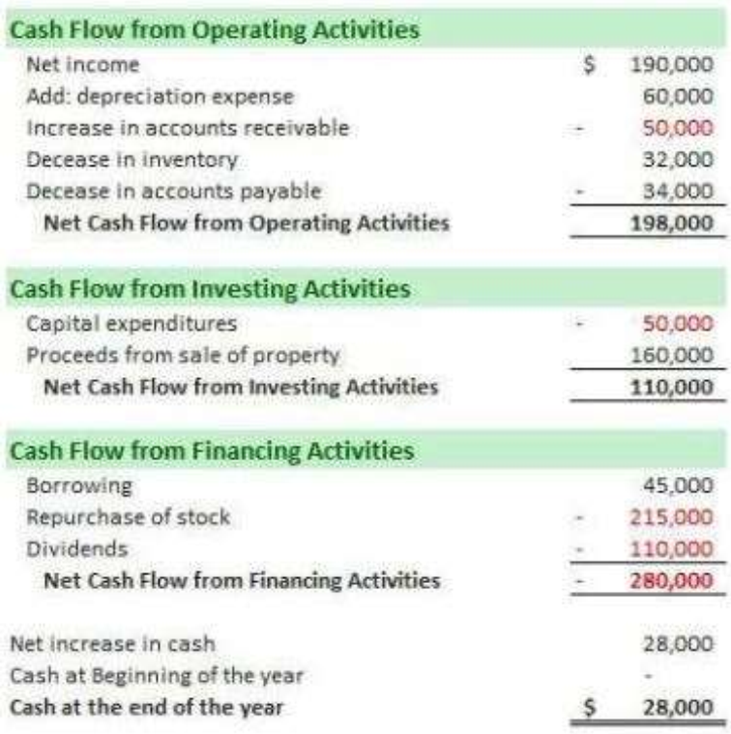
All companies in the US publish their financial statements on this website.

Earnings
- Earnings (E): the net profit made by a company in a period.
- Earnings Per Share (EPS): earnings made in a period divided by the number of shares outstanding.
- Price to Earnings (PE): the ratio of the company’s share price to the company’s EPS. It tells you how much you pay for each dollar of earnings. It is used to see if a company is overvalued or undervalued.
We said that the net profit or the earnings of a company is their revenue minus their expenses. As a shareholder of the company, you definitely want the company’s earnings to get higher so that your portion of earnings increases as well, so earnings is one of the important numbers to look at when you’re investing in any company. However, earnings is not a sufficient metric to look at. Consider the following example:
Company | ABC | XYZ
Earnings | $1,000,000 | $2,000,000
Which company would you prefer to invest in? Well, you might think “we need to look at the cash flow statement of each company to make sure that these earnings are from a recurring source”. Okay, assume it is from a recurring source, which one to choose? You must first know the shares outstanding of each company! Let it be as follows:
Company | ABC | XYZ
Earnings | $1,000,000 | $2,000,000
Shares Outstanding | 200,000 | 1,000,000
So, if you own 1 share in company ABC, you earn $\frac{\$1,000,000}{200,000}=\$10$, while if you own 1 share in company XYZ, you earn $\frac{\$2,000,000}{1,000,000}=\$2$. See? Although company XYZ’s earnings are higher than company ABC, investing in company ABC is better because your Earnings Per Share (EPS) is higher. So, the metric EPS is more important than just looking at the earnings of a company.
Company | ABC | XYZ
Earnings | $1,000,000 | $2,000,000
Shares Outstanding | 200,000 | 1,000,000
EPS | $10 | $2
However, looking at the EPS is not sufficient. Why? Because it tells you the earnings per share, but what if that one share is actually very expensive? For example:
Company | ABC | XYZ
Earnings | $1,000,000 | $2,000,000
Shares Outstanding | 200,000 | 1,000,000
EPS | $10 | $2
Share Value | $480 | $30
So, although you earn $10 per share of company ABC to only $2 per share in XYZ, ABC’s share is very expensive compared to XYZ. Instead of buying 1 share in ABC for $480 and make a profit of $10, you can buy $\frac{\$480}{\$30}=16$ shares in XYZ and make a total profit of $16×\$2=\$32$! Thus, instead of just looking at the EPS of a company, we look at the Price to Earnings (PE) of a company. The lower the PE, the higher our earnings.
Company | ABC | XYZ
Earnings | $1,000,000 | $2,000,000
Shares Outstanding | 200,000 | 1,000,000
EPS | $10 | $2
Share Price | $480 | $30
PE | 48 | 15
Real example: search for Walmart company on Finviz. You would get a lot of information as shown below.
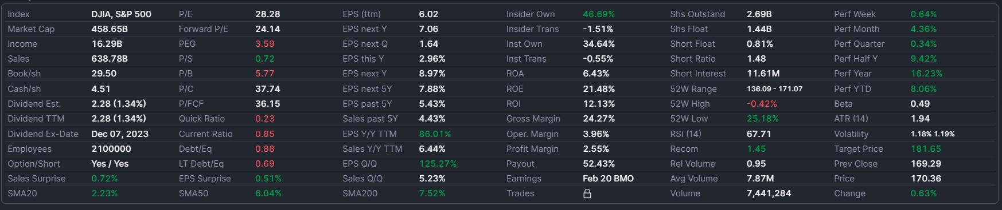
You can find the following information:
- Shares Outstanding = 2.69B.
- EPS = $6.02.
- Share Price = $170.36.
- PE = 28.28.
Let’s compare it with Netflix for example:
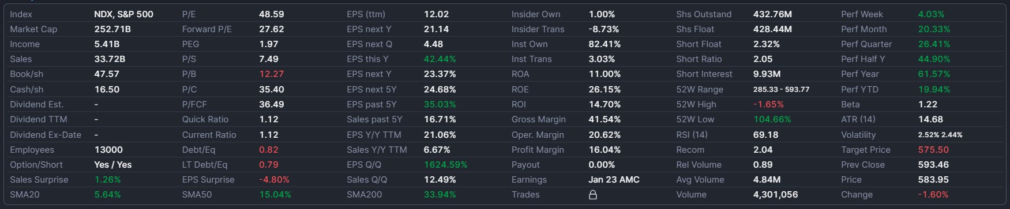
- Shares Outstanding = 432.76M.
- EPS = $12.02.
- Share Price = $583.95.
- PE = 48.59.
So, at the moment these screenshots were taken, it seems like Walmart is a better option compared to Netflix since $PE{\left.​\right|}_{Walmart}<PE{\left.​\right|}_{Netflix}$. This happened because Netflix’s share price is more expensive.
So, we reached a conclusion that PE is the best metric to look at to compare between companies. However, it is still not enough. For example, in 2020 during the COVID pandemic, the PE of Tesla was extremely large, it was 1130.26! Why did that happen? $PE=\frac{Share Price}{EPS}$, so, Tesla’s share price was very expensive, which means a lot of investors wanted to invest in Tesla, however the earnings of the company were not great and hence their EPS was small, so the PE was very large. But why did investors want to invest in Tesla although their earnings per share were not great at that time? Because when you are investing in a company, you have two approaches: one approach is to invest in a big and well-known company that is making good money now. Another approach is to look for companies that aren’t making good money now, but they have potential and expected to grow in the future, so you buy their shares in advance, so you make huge earnings in the future. This is what investors were thinking when they invested in Tesla, and they were right, today, Tesla’s PE is only 46.47, which shows that Tesla has indeed grown! So, when the PE of a company is large, it is most probably that the company is not making good money now, but investors believe it will grow in the future. This is why there is another quantity rather than PE called Forward PE, which is the expected PE of a company in the next year; analysts try to project/expect the earnings of a company in the next year. An example of a company that currently shows a high PE is Merck & Co as shown below:
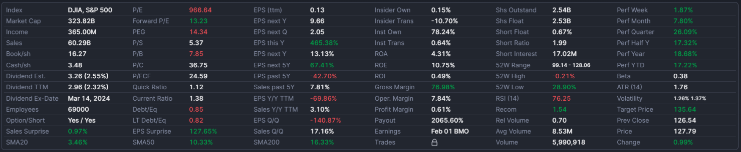
Its current PE is 966.64, while its forward PE is 13.23! So, analysts expect this company to have much larger earnings next year.

Book Value
- Book Value: it represents the total amount a company is worth if all assets are sold and all liabilities are paid back.
- Book Value Per Share (BVPS): book value divided by shares outstanding.
- Price to Book Value (PB): shares price divided by BVPS. It tells you how much you pay for each dollar of book value.
So, assume a company decided to shut down. It will sell all its assets and pay back their liabilities. How much money will be available is the book value. This book value will then be divided among shareholders. So, we divide this book value by the shares outstanding to know the book value per share. This tells us how much we would get if the company we are investing in shut down. For example, shown below is the statistics of Netflix. On the left, you can see the book value per share is $47.57, while the current share price is $583.95. So, you are now investing an amount of $583.95 for every share, while if the company shut down the price per share will only be $47.57! So, if you own 10 shares, you have paid 10 x $583.95 = $5839.5 to buy these shares, but you would only get 10 x $47.57 = $475.7 if the company decided to shut down.

So, the book value per share let us know how much it is risky for us to lose our money if the company shut down at any time. Of course, we would like the book value per share to be as high as possible so that we are on the safe side that, even if the company shut down at any time, we don’t lose a lot. You can think of the book value per share as the effective share value of the company. That is, people’s excitement to buy the company’s shares led the price share to a certain price, while the actual price of the share if the company shut down is the book value per share.
To compare this between different companies, we look at price to book value. The smaller the price to book value ratio, the safer we are if the company shut down at any time.
So, notice that what might make the PE or PB of a company high is actually the investors speculating that the company will grow in the future! The investors believe that the company’s earnings will grow in the future, so they fight to buy the company’s shares, so the company’s share price goes higher, but at the same time the company’s earnings are still not high, so the PE ratio gets high, and the company is still not mature enough that if it shut down, its book value won’t be high, so the PB ratio gets high.

Dividends
- Dividend: it is a distribution of profits by a corporation to its shareholders. When a corporation earns a profit or surplus, it is able to pay a proportion of the profit as a dividend to shareholders. Any amount not distributed is taken to be re-invested in the business.
- Declaration date: the date when the company declares they will pay a dividend.
- Record date: the company records the names of all shareholders at the end of this day. These shareholders are the ones who will receive the dividend.
- Ex-dividend date: If you buy on this date or after, you will no longer receive the dividend. In North America, stocks take two business days to settle (think of it as it takes 2 business days for your name to be on the stock certificate). Because of this, ex-dividend date will be one business day before the record date (always check the ex-dividend date online because of holidays and weekends).
- Dividend amount: the amount of money paid per share.
- Dividend yield: the annual dividends paid divided by the current share price. This tells us how much the dividends are in percentage.
So, you are now a shareholder of a company that made a profit. The company has a board of directors who decide what to do with this profit. They can either decide that this profit will be kept in the company to grow it more, so they are reinvesting the profit in the company, or they distribute this profit as a dividend on the shareholders. Some companies pay dividends on a periodic basis, some do not pay dividends at all. For example, Walmart paid a dividend of $0.57 per share on the 7th of December, 2023 as shown below. So, if you have owned 100 shares before this date, you would have got $57.
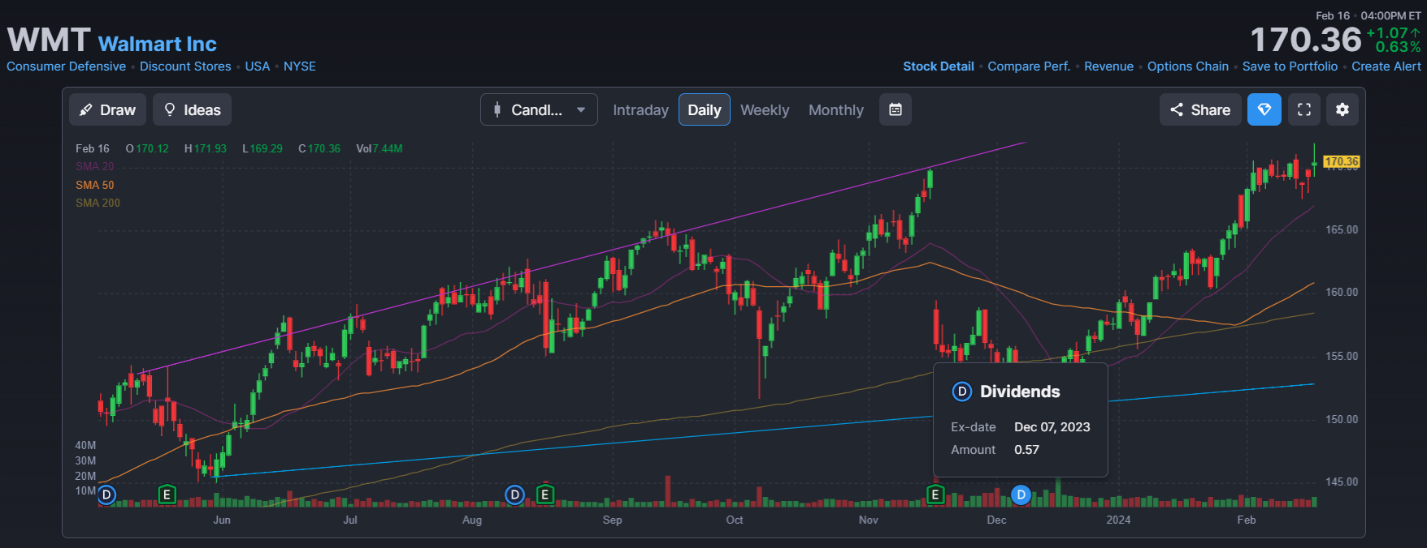
So, who get these dividends? Shareholders who bought their shares before the ex-dividend date, so always check for the ex-dividend date and buy before it. Dividend.com is a website that scans dividend dates for the US stock market.
Shown below is an example for Walmart. The next dividend declaration date is on the 4th of January, 2021 for an amount of $0.54 per share. The ex-dividend date is 10th of December, 2020. Thus, if you bought shares before the 10th of December 2020, you would get a dividend on the 4th of January 2021.
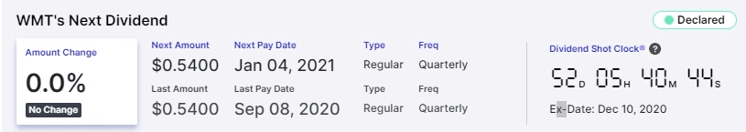
Notice that you don’t need to hold shares after the ex-dividend date to get the dividend. For example, you can buy Walmart’s shares on the 9th of December, sell them on the 11th of December, and still get a dividend on the 4th of January! So, why don’t we just keep buying companies’ shares a day before the ex-dividend date, sell them after the ex-dividend date, and keep making profits that way? Because it doesn’t work like that. When a company announces an ex-dividend date, its share price drops by the value of the dividend the next day. For example, assume a company announced their ex-dividend date to be the 13th of June with a dividend value of $0.5. Their share price until the 13th of June was $57. What happens next day on the 14th of June? When the market opens, the share’s price drop to $57 - $0.5 = $56.5. So, if you bought 10 shares before the ex-dividend date, say on the 12th of June, for $57 x 10 = $570 to get a dividend of $0.5 x 10 = $5, then you decided to sell these shares on the 14th of June, you would sell them for $56.5 x 10 = $565. So, you started with $570 and ended with $565 + $5 = $570. But why does this happen? Think about it, the company is giving out the dividend value for each share, so the company’s worth decreased by that much. Accordingly, its share price decreases by this amount. It is not a must that the share’s price decreases by exactly the dividend value, maybe a little less, maybe a little more.

Growth vs Value Stocks
When you decide to invest in a company, there are two approaches:
- Growth Companies: companies that are not making as much income relative to their price, but that are expected to have high earnings growth in the future. They usually have a high PE ratio, high PB ratio, and do not give out dividends.
- Value Companies: companies that are mature and generating good income relative to their price. These companies are not expected to grow their income by much in the future. They usually have a low PE ratio, low PB ratio, and give out dividends.
It makes sense that growth companies do not give out dividends, while value companies do, right? Because growth companies still have many ideas, plans, and projects that they want to implement to grow their company, so they don’t give out any dividends because they reinvest all these money in the company. On the other hand, value companies are pretty mature companies that do not really have any growth potential or out-of-the-box ideas/projects, they are just good at what they are already doing now.
Warren Buffett prefers investing in value companies. He finds them safer that even if they shut down at any time, he won’t lose a lot (since their PB ratio is low).

Technical vs Fundamental Analysis
When you want to analyze a company’s stock, there are two ways:
- Technical analysis: the study of charts (price and volume) to predict future price movement.
- Fundamental analysis: the analysis of everything that can impact the financial health of the company: earnings, competitors, economy, interest rates, employment, laws, etc.
Short-term investors rely on technical analysis. But as a long-term investor, need to do fundamental analysis. It makes sense because short-term investors that do speculations won’t really be so much interested in knowing everything about a company, they just check the chart and feel that the price might go up in two days for example, so they buy now and sell two days later. But as a long-term investor, you want to make sure that the company will be doing good on the long run because you will be a shareholder for a long time.

